Anti-Vandal Toilet Paper Dispenser
STAINLESS STEEL TWO-PIECE DISPENSERS:
CALL OR E-MAIL FOR PRICE
CONTACT:
PHN: 510. 328 3111
EMAIL: sales@sanipaper.com
TITLE:
STAINLESS STEEL TWO-PIECE DISPENSERS:

SKU: TPD0250SR-1

SUMMARY:

Two-piece, dual-roll design with a slow-rolling mechanism, friction sleeve, and stainless-steel construction.

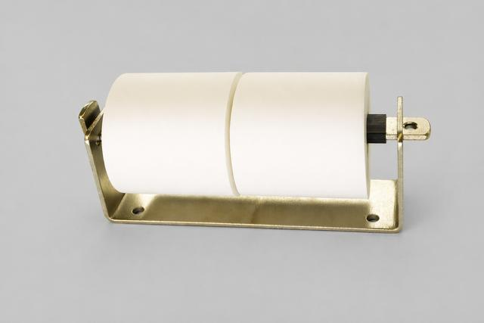

Configuration
This unit is a two-piece, dual-roll, slow-rolling stainless-steel dispenser equipped with a friction sleeve. It is ADA-compliant and specifically engineered for installation on masonry walls, featuring four widely spaced mounting holes with a 7/16” diameter. The bar includes a 3/8” diameter hole designed for a lock (lock not included). The overall dimensions are approximately 13 inches in length and 3 inches in width.

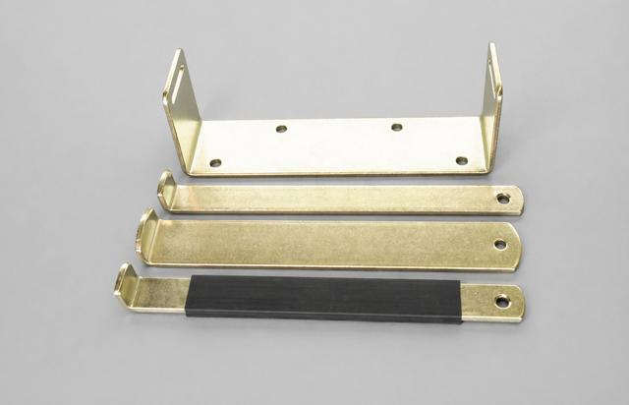

Configuration
This is a two-piece, dual-roll stainless steel dispenser (shown without paper to highlight the mounting hole spacing). The TPD0250SR-1 model comes equipped with a slow-rolling bar fitted with a black neoprene friction sleeve, as shown in the foreground. This design allows the tissue to dispense smoothly while minimizing uncontrolled spinning and reducing waste from excessive pulling. The interchangeable lock-bar options allow the unit to be configured in three different ways.

CALL OR E-MAIL FOR PRICE

CONTACT:
TEL: 510. 328 3111
EMAIL: sales@sanipaper.com

TITLE:

STAINLESS STEEL TWO-PIECE DISPENSERS:

SKU: TPD0250NB-2

SUMMARY:

Two-piece, dual-roll design with a free-rolling mechanism, narrow bar, and stainless-steel construction.
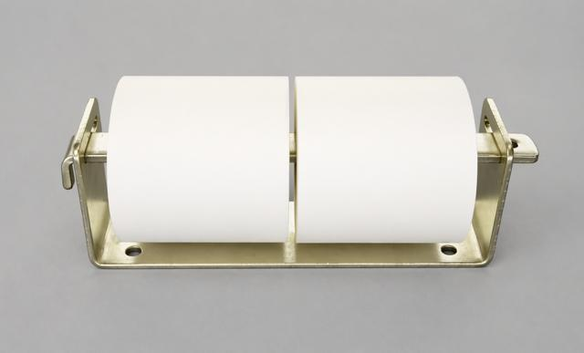

Durable stainless-steel dispenser featuring a two-piece, two-roll, free-rolling narrow-bar design. ADA compliant and engineered for secure mounting on masonry walls with four wide-spaced 7/16” mounting holes. The bar includes a 3/8” hole for optional locking (lock not included). Approximate size: 13” long × 3” wide.

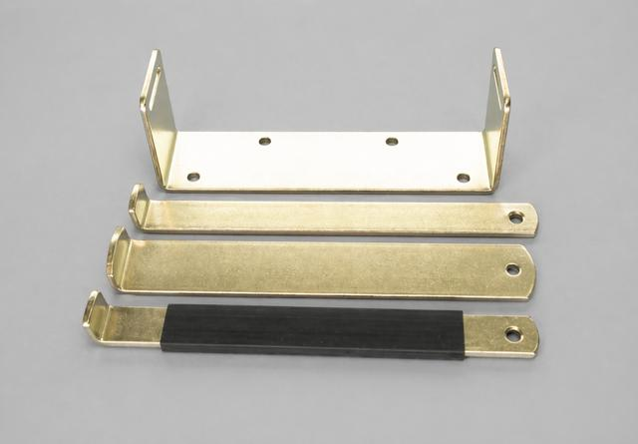

Two-piece, two-roll stainless steel dispenser, shown without paper to highlight mounting hole spacing. The TPD0250NB-2 comes equipped with a 1-1/4” wide narrow bar, with the sleeve-free bar displayed alongside the mounting bracket. Interchangeable lock-bar options offer three configurable setups. Optional friction sleeves can be added to convert the narrow bar into a slow-rolling system.

CALL OR E-MAIL FOR PRICE

CONTACT:
PHN: 510. 328 3111
EMAIL: sales@sanipaper.com

TITLE:

STAINLESS STEEL TWO -PIECE DISPENSERS:

SKU: TPD0250WB-3

SUMMARY:

Two-piece, dual-roll design with fixed rollers, wide bar, and stainless-steel construction.

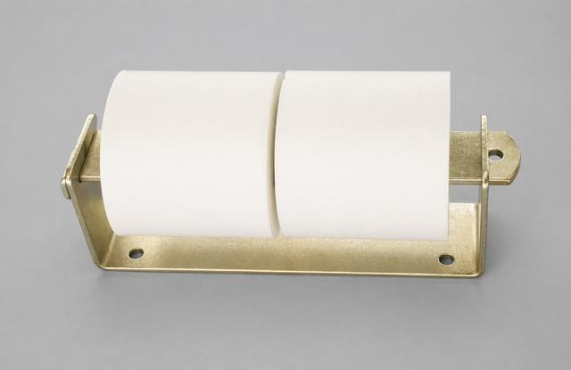

This two-piece, dual-roll stainless steel dispenser is shown without paper to illustrate the mounting hole spacing. The TPD0250WB-3 model is equipped with a 2-inch-wide bar that prevents the roll from rotating, requiring users to manually pull and unwrap the paper. The dispenser supports interchangeable lock-bar styles, allowing for three different configuration options. The two-roll wide bar is displayed between the narrow bar and the narrow bar with a friction sleeve.

This unit is a non-rolling, wide-bar stainless steel dispenser and is not ADA compliant. It is specifically designed for installation on masonry walls, featuring four widely spaced mounting holes with a 7/16-inch diameter. The bar includes a 3/8-inch diameter hole for a lock (lock not included). Overall dimensions are approximately 13 inches in length and 3 inches in width.

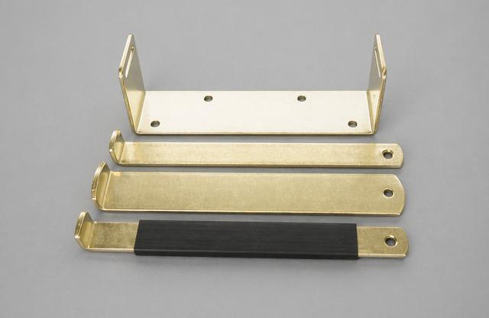

Two-piece, two-roll stainless steel dispenser (shown without paper) illustrating mounting hole spacing.
The TPD0250WB-3 model is equipped with a 2-inch-wide bar that prevents the roll from rotating, requiring users to manually pull and unwrap the paper as needed.

Interchangeable lock-bar styles allow for three different dispenser configurations.
The two-roll wide-bar configuration is positioned between the narrow-bar and the narrow-bar with friction sleeve options.

STAINLESS STEEL THREE-PIECE DISPENSERS:

CALL OR E-MAIL FOR PRICE

CONTACT:
TEL: 510. 328 3111
EMAIL: sales@sanipaper.com

TITLE:

STAINLESS STEEL THREE-PIECE DISPENSERS:

SKU: TPD0350SR-4

SUMMARY:

Two-piece, three-roll design with a slow-rolling mechanism, friction sleeve, and stainless-steel construction.
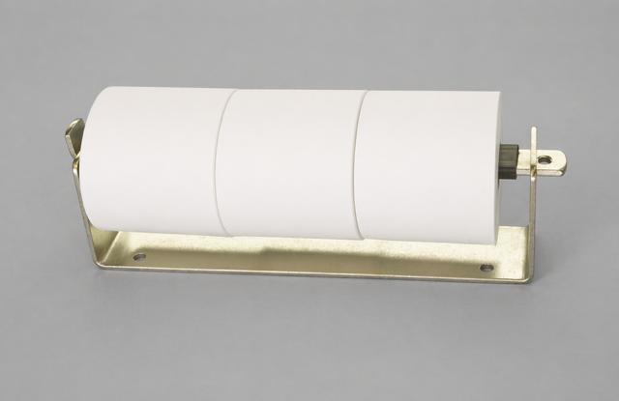
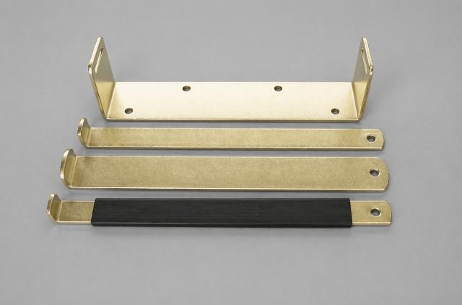

Two-piece, three-roll stainless steel dispenser featuring a slow-rolling narrow bar with a neoprene friction sleeve. Designed to be ADA compliant, this unit provides controlled roll rotation to help reduce waste.
Specifically engineered for installation on masonry walls, it includes four wide-spaced mounting holes (7/16” diameter) for secure attachment. The bar is equipped with a 3/8” diameter hole for a locking mechanism (lock not included).
Overall dimensions: approximately 17” (L) x 3” (W).

Two-piece, three-roll stainless steel dispenser (shown without paper) illustrating mounting hole spacing.
The TPD0350SR-4 model features a 1-1/4” narrow bar with a friction sleeve, allowing the rolls to rotate while providing controlled resistance to minimize free-spooling and reduce paper waste.

Interchangeable lock-bar styles enable three different dispenser configurations.
The three-roll slow-rolling bar with friction sleeve is shown in the foreground.

CALL OR E-MAIL FOR PRICE

CONTACT:
TEL: 510. 328 3111
EMAIL: sales@sanipaper.com

TITLE:

STAINLESS STEEL THREE-PIECE DISPENSERS:

SKU: TPD0350WB-5

SUMMARY:

Two-piece, three-roll design with fixed rollers and stainless-steel construction.

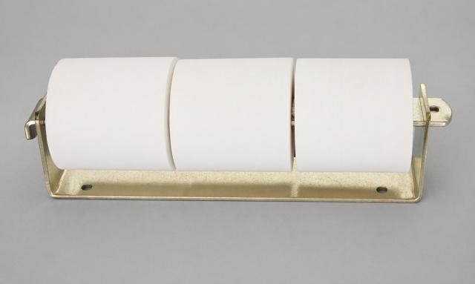

This two-piece, three-roll stainless steel dispenser features a non-rolling wide bar design. It is not ADA compliant. The unit is specifically engineered for installation on masonry walls and includes four widely spaced mounting holes with a 7/16-inch diameter. The bar is equipped with a 3/8-inch diameter hole for a lock (lock not included). Overall dimensions are approximately 17 inches in length and 3 inches in width.

Two-piece, three-roll stainless steel dispenser (shown without paper) illustrating mounting hole spacing.
The TPD0350WB- 5 model is equipped with a 2” wide bar that prevents the roll from rotating, requiring users to dispense paper sheet-by-sheet.

Interchangeable lock-bar styles allow for three different dispenser configurations.
The three-roll wide-bar configuration is shown between the narrow-bar and the narrow-bar with friction sleeve options.

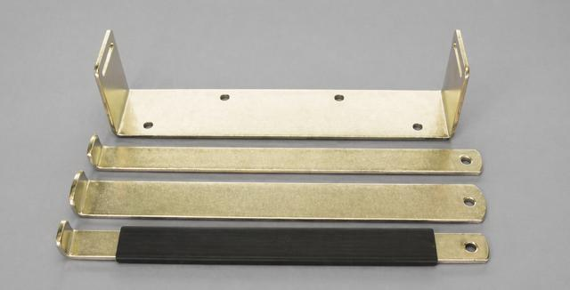

CALL OR E-MAIL FOR PRICE

CONTACT:
TEL: 510. 328 3111
EMAIL: sales@sanipaper.com

TITLE:

STAINLESS STEEL THREE-PIECE DISPENSERS:

SKU: TPD0350WB-6

SUMMARY:

Stainless steel, two-piece, three-roll, non-rolling design

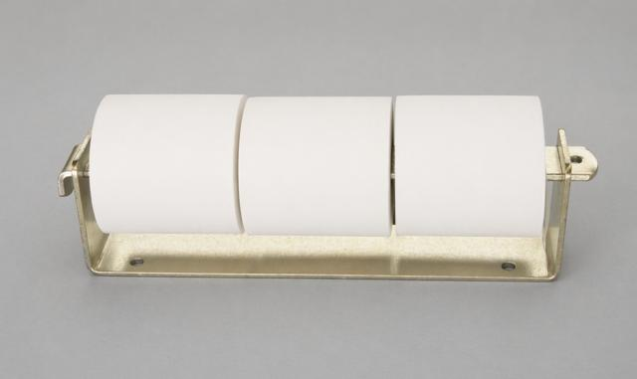

This is a two-piece, three-roll stainless steel dispenser with a non-rotating wide bar design. It is not ADA compliant. The unit is specifically designed for mounting on masonry walls and features four widely spaced mounting holes, each measuring 7/16 inch in diameter. The bar includes a 3/8-inch diameter hole for a lock (lock not included). Overall dimensions are approximately 17 inches in length and 3 inches in width.

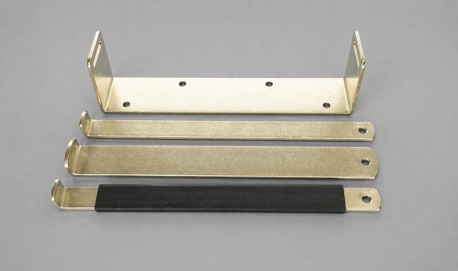

This two-piece, three-roll stainless steel dispenser is shown without paper to display the mounting hole spacing. The TPD0350WB-6 model features a 2-inch-wide bar that prevents the rolls from rotating, requiring users to pull and unwrap the paper manually, sheet by sheet. The unit includes interchangeable lock-bar styles, allowing for three different configuration options. The three-roll wide bar is shown positioned between the narrow bar and the narrow bar with a friction sleeve.

