STAINLESS STEEL TWO-PIECE DISPENSERS:

CALL OR E-MAIL FOR PRICE

CONTACT:
TEL: 510. 328 3111
EMAIL: sales@sanipaper.com
TITLE:
STAINLESS STEEL TWO-PIECE DISPENSERS:
SKU: TPD0200SR-7

SUMMARY:
Three-piece, dual-roll design with a slow-rolling mechanism, friction sleeve, and stainless-steel construction.

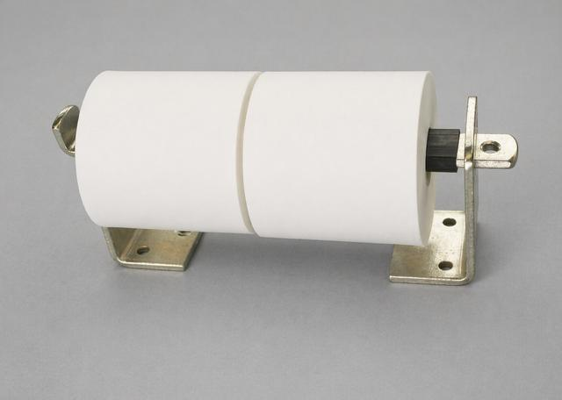

Configuration
This is a three-piece, dual-roll stainless steel dispenser featuring a slow-rolling bar with a friction sleeve. It is ADA compliant and designed for flexible installation, accommodating wall-stud spacing or partition mounting. The unit includes six closely spaced mounting holes for screws up to 5/16 inch in diameter. The bar also has a 3/8-inch diameter hole for a lock (lock not included). Overall dimensions are approximately 13 inches in length and 3 inches in width.

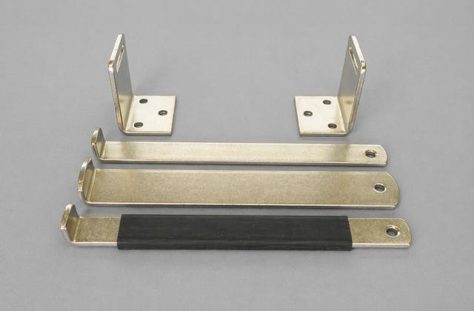
This three-piece, dual-roll stainless steel dispenser is shown without paper to highlight the mounting hole spacing. The TPD0200SR- 7 model is equipped with a slow-rolling bar featuring a black neoprene friction sleeve, as shown in the foreground. This design allows smooth, unrestricted tissue dispensing while minimizing free spinning and reducing unnecessary paper waste. The unit also supports interchangeable lock-bar styles, offering three different configuration options.

CALL OR E-MAIL FOR PRICE

CONTACT:
PHN: 510. 328 3111
EMAIL: sales@sanipaper.com

TITLE:

STAINLESS STEEL TWO-PIECE DISPENSERS:

SKU: TPD0200NB-8

SUMMARY:

Three-piece, dual-roll design with a free-rolling mechanism, narrow bar, and stainless-steel construction.

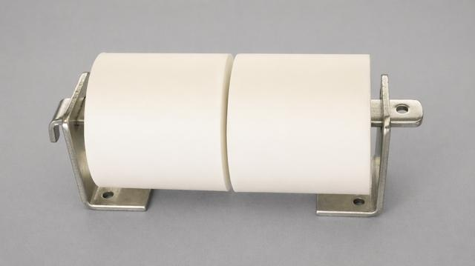

This is a three-piece, dual-roll stainless steel dispenser with a free-rolling narrow bar design. It is ADA compliant and engineered for flexible installation, allowing it to align with wall-stud spacing or be mounted on partitions. The unit features six closely spaced mounting holes designed for screws up to 5/16 inch in diameter. The bar includes a 3/8-inch diameter hole for a lock (lock not included). Overall dimensions are approximately 13 inches in length and 3 inches in width.

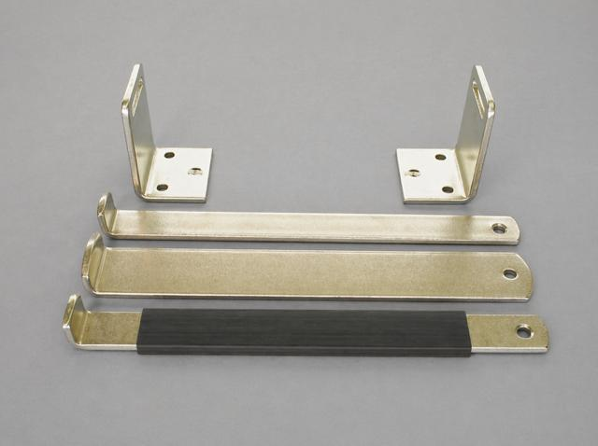

This three-piece, dual-roll stainless steel dispenser is shown without paper to display the mounting hole spacing. The TPD0200NB- 8 model comes with a 1-1/4 inch wide free-rolling narrow bar, shown next to the mounting brackets. The unit features interchangeable lock-bar styles, allowing for three different configuration options. Friction sleeves can be purchased separately to convert the free-rolling narrow bar into a slow-rolling version if desired.

CALL OR E-MAIL FOR PRICE

CONTACT:
TEL: 510. 328 3111
EMAIL: sales@sanipaper.com

TITLE:

STAINLESS STEEL TWO-PIECE DISPENSERS:

SKU: TPD0200WB-9

Three-piece, dual-roll design with fixed rollers, wide bar, and stainless-steel construction.

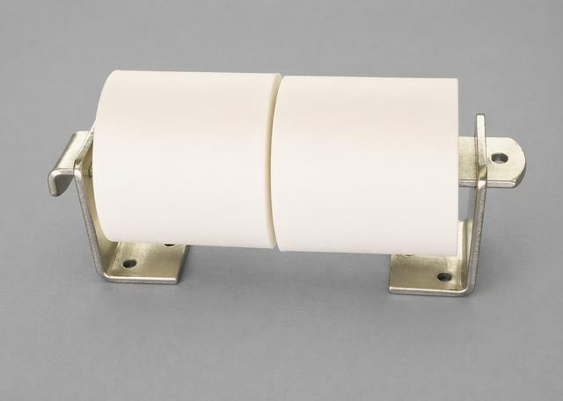

Configuration
This three-piece, dual-roll stainless steel dispenser features a non-rotating wide-bar design and is not ADA compliant. It is built for flexible installation, allowing alignment with wall studs or partition mounting, and includes six closely spaced holes for screws up to 5/16 inch in diameter. The 2-inch-wide bar prevents the rolls from turning, requiring users to manually pull and unwrap the paper as needed. The bar also includes a 3/8-inch diameter hole for a lock (lock not included). Overall dimensions are approximately 13 inches in length and 3 inches in width.

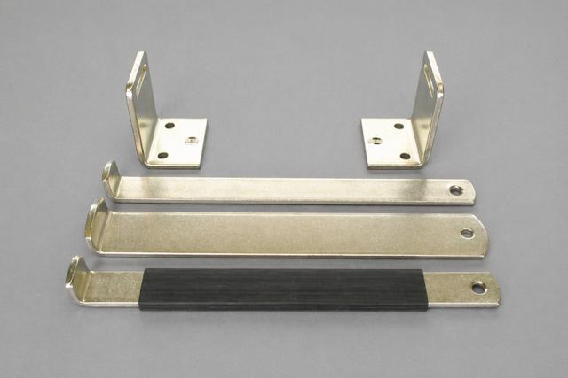

This three-piece, dual-roll stainless steel dispenser is shown without paper to highlight the mounting hole spacing. The TPD0200WB-9 model is equipped with a 2-inch-wide bar, shown positioned between the narrow bar and the slow-rolling bar with a friction sleeve. The unit features interchangeable lock-bar styles, allowing for three different configuration options.

CALL OR E-MAIL FOR PRICE

CONTACT:
TEL: 510. 328 3111
EMAIL: sales@sanipaper.com

TITLE:

STAINLESS STEEL THREE-PIECE DISPENSERS: white powder coat enamel steel dispenser

SKU: TPD0300SR-10

SUMMARY:
Three-piece, three-roll design with a slow-rolling mechanism, friction sleeve, and stainless-steel construction.

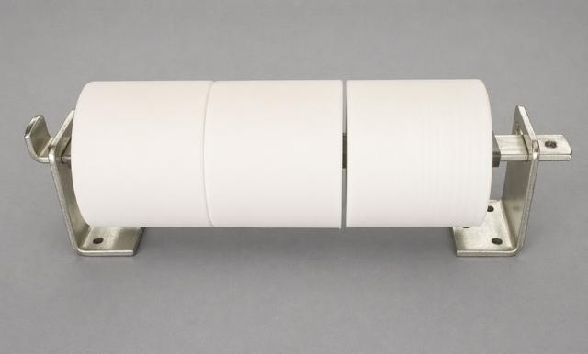

Configuration
This three-piece, three-roll stainless steel dispenser features a slow-rolling narrow bar with a friction sleeve and is ADA compliant. It is designed for flexible installation, allowing alignment with wall-stud spacing or partition mounting, and includes six closely spaced holes for screws up to 5/16 inch in diameter. The slow-rolling bar with friction sleeve enables smooth, unrestricted paper dispensing while reducing free spinning and minimizing waste. The bar also includes a 3/8-inch diameter hole for a lock (lock not included). Overall dimensions are approximately 19 inches in length and 3 inches in width.

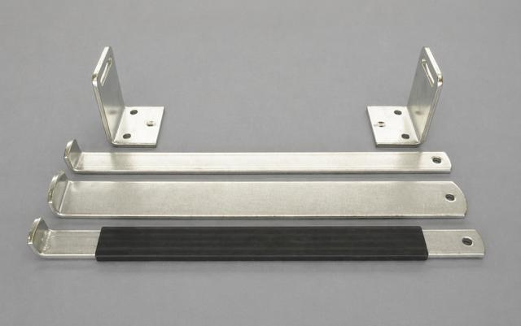

This three-piece, three-roll stainless steel dispenser is shown without paper to highlight the mounting hole spacing. The TPD0300SR-10 model comes equipped with a slow-rolling narrow bar featuring a neoprene friction sleeve, shown in the foreground. The unit also offers interchangeable lock-bar styles, allowing for three different configuration options.

CALL OR E-MAIL FOR PRICE

CONTACT:
PHN: 510. 328 3111
EMAIL: sales@sanipaper.com

TITLE:

TAINLESS STEEL THREE-PIECE DISPENSERS: white Powder coat enamel steel dispenser

SKU: TPD0300NB-11

SUMMURY:

Three-piece, three-roll design with a free-rolling mechanism, narrow bar, and stainless-steel construction.
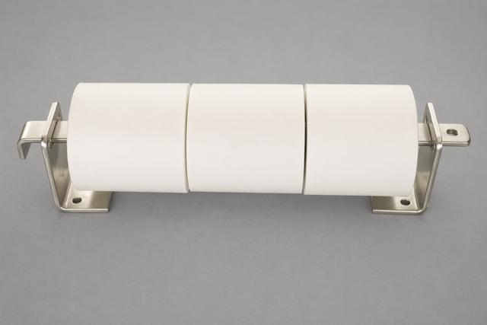

This three-piece, three-roll stainless steel dispenser features a free-rolling narrow bar without a sleeve and is ADA compliant. It is designed for flexible installation, allowing alignment with wall studs or partition mounting, and includes six closely spaced holes for screws up to 5/16 inch in diameter. The 1-1/4-inch-wide bar allows the rolls to rotate freely for easy dispensing. The bar also includes a 3/8-inch diameter hole for a lock (lock not included). Overall dimensions are approximately 19 inches in length and 3 inches in width.

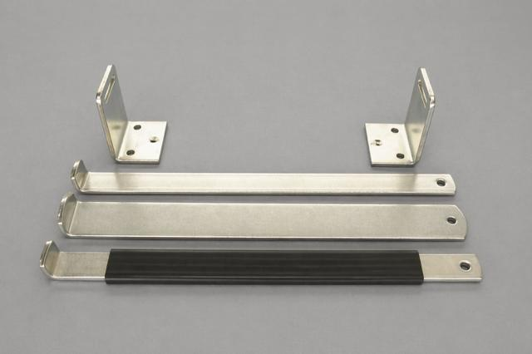

This three-piece, three-roll stainless steel dispenser is shown without paper to illustrate the mounting hole spacing. The TPD0300NB-11 model comes equipped with a narrow bar, shown next to the mounting brackets. The unit features interchangeable lock-bar styles, allowing for three different configuration options. Friction sleeves can be purchased separately to upgrade the narrow bar to a slow-rolling version if desired.

CALL OR E-MAIL FOR PRICE

CONTACT:
TEL: 510. 328 3111
EMAIL: sales@sanipaper.com

TITLE:

TAINLESS STEEL THREE-PIECE DISPENSERS: white powdercoat enamel steel dispenser

SKU : TPD0300WB-12

SUMMARY:

Three-piece, three-roll design with fixed rollers, wide bar, and stainless-steel construction.

This three-piece, three-roll stainless steel dispenser features a non-rotating wide-bar design and is not ADA compliant. It is engineered for flexible installation, accommodating wall-stud spacing or partition mounting, and includes six closely spaced holes for screws up to 5/16 inch in diameter. The 2-inch-wide bar prevents the rolls from turning, requiring users to pull and dispense the paper manually, sheet by sheet. The bar also includes a 3/8-inch diameter hole for a lock (lock not included). Overall dimensions are approximately 19 inches in length and 3 inches in width.

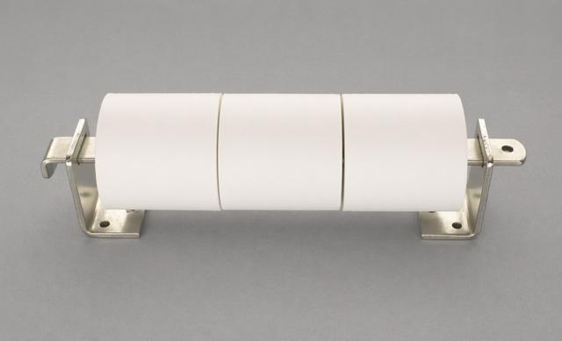

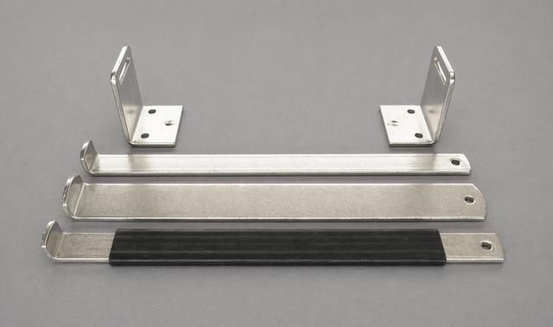

This three-piece, three-roll stainless steel dispenser is shown without paper to illustrate the mounting hole spacing. The TPD0300WB-12 model is equipped with a 2-inch-wide bar that prevents the rolls from rotating, requiring users to manually pull and unwrap the tissue as needed. The wide bar is shown positioned between the narrow bar and the slow-rolling bar with a friction sleeve. The unit also features interchangeable lock-bar styles, allowing for three different configuration options.

